|  |
| --- |
| **Exercise 2** |

**Copy this file and open it in Word or some other editor where you can insert images. Be sure to read "How to Copy the Results of a Query" found in Module 2 in Canvas.    This is how you will be answering the following questions.**

Using the Premier_Products database, answer the following questions:

1. Display all the information about each customer.  Insert your query and results here.

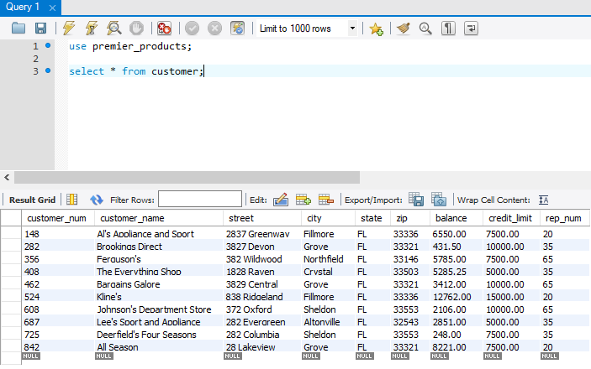

1. List the order number for each order placed by customer 148 on October 23, 2015.    Copy the results of the query here.

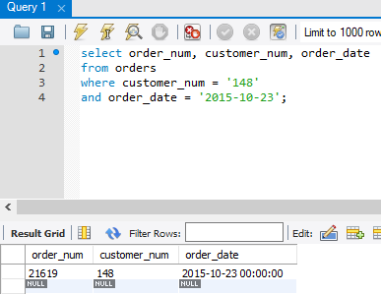

1. List the customers who have a balance greater than $5000 and reside in either Northfield or Fillmore.   Copy the results of the query here.

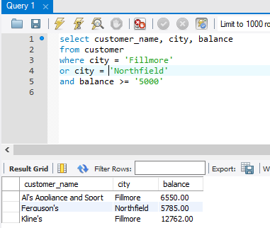

1. List the details of all parts.  Order the output by part description.   Limit your search to the first 5 rows.  Copy the results of the query here.

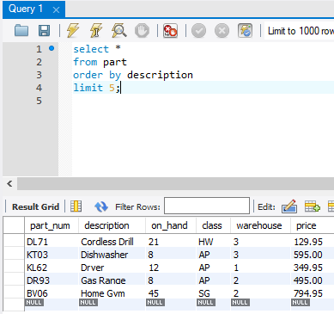

1. List all the details of all parts.   Order the output by part number within item class.   Copy the results of the query here.

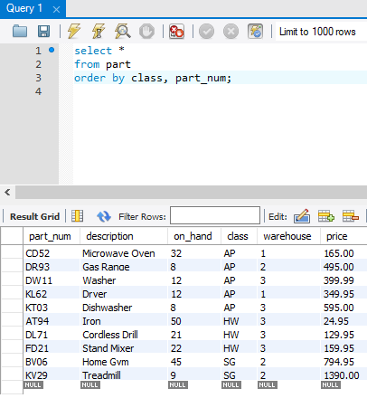

Using the Henry Books database, answer the following questions:

1. Display the contents of the branch table. Insert your query and results here:

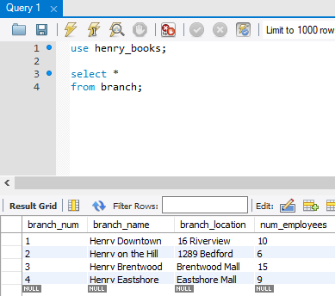

1. List the publisher code and name of the publishers not from New York in descending order. Insert your query and results here:

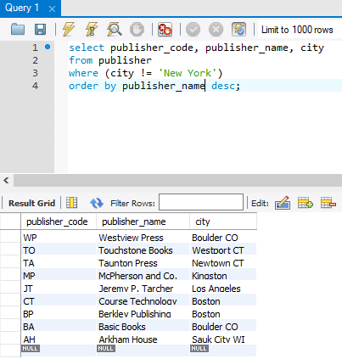

1. Display the author number for the author whose last name is Rowling or Salinger. Insert your query and results here:

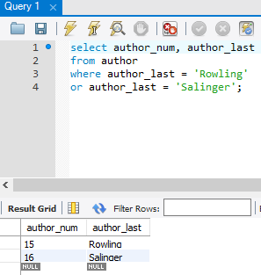

1. Display the book code, title, type, and price for all books with a price of $10.00 or less. Display the results in descending order by title. Insert your query and results here:

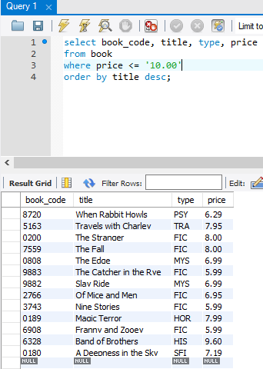

1. Display the book code, branch number, and the number on hand if there are more than 3 copies of a book in inventory. Display the information in branch number order. Insert your query and results here:

